15.AIM:-To implement UML diagrams for Blood Bank Registration System..

1.USE CASE:

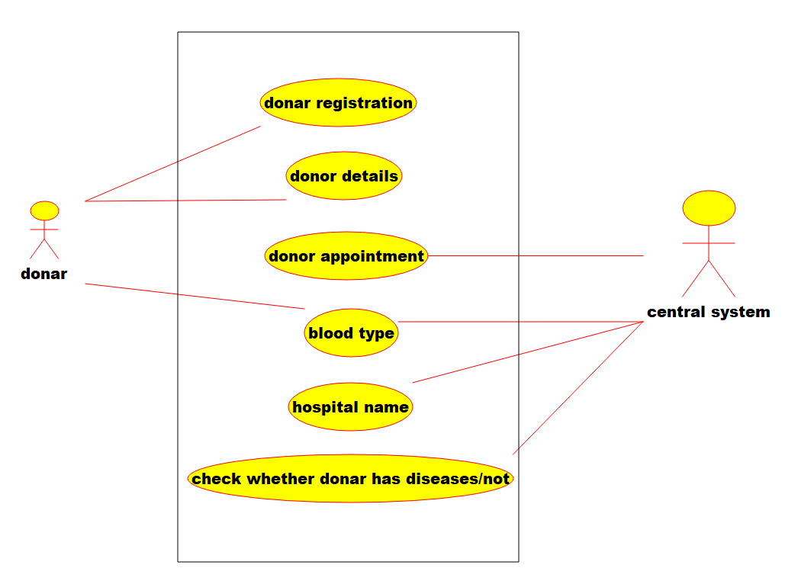

2.COLLABORATION DIAGRAM:-

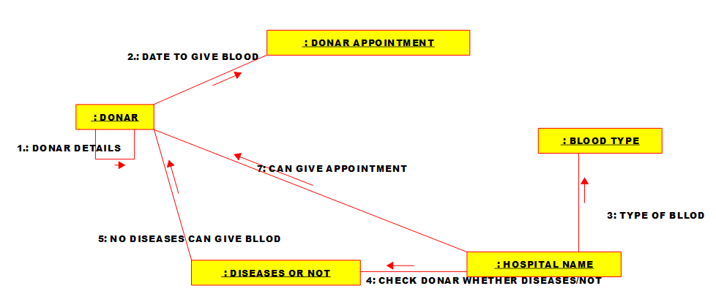

3.STATECHART DIAGRAM:-

